Stroke Risk with Chiropractic Care?
Not According to the Scientific Literature
We’ve all seen the billboards and buses, scaring the public, suggesting that they will have a stroke if they are treated by a chiropractor. When I first saw the billboard several years ago, I assumed that it was a law firm looking for a new niche. I later learned that it was a well-funded anti-chiropractic group that “claim” to have been injured by chiropractic manipulation. My first impression was that they will fizzle out with time, but I’ve seen more billboards and propaganda. So, I thought I would tackle this fallacy with a literature review that looks at the largest and most recent scientific investigation on the subject.

The study was published in February 2008 in SPINE, one of the most prestigious orthopedic journals. It is titled Risk of Vertebrobasilar Stroke and Chiropractic Care: Results of a Population-Based Case-Control and Case-Crossover Study (SPINE, Volume 33, Number 4S, pp S176–S183). The study included 818 cases of vertibrobasilar strokes that were admitted to Ontario hospitals between 1993 and 2002. VBA strokes are the types that are supposedly related to chiropractic manipulation. The study looked at the distribution of VBA stroke patients between chiropractors and primary care physicians (PCP); the latter obviously don’t perform spinal manipulation. Therefore, if chiropractic treatments provoke VBA strokes, we would expect to see a far greater association of victims with the chiropractic group than the PCP group. This was not the case. The results were interesting and exonerate the chiropractic profession. The American Chiropractic Association offers these key points from the study:
- The study, which analyzed nine-years’ worth of data, concluded that vertebrobasilar artery (VBA) stroke is a very rare event.
- According to the study, the risk of VBA stroke associated with a visit to a chiropractor’s office appears to be no different than the risk of VBA stroke following a visit to the office of a primary care physician.
- Furthermore, any observed association between a VBA stroke and chiropractic manipulation (as well as its apparent association with PCP visits) is likely due to patients with an undiagnosed vertebral artery dissection seeking care for neck pain and headache prior to their stroke.
- This most recent evidence, which was published in the Feb. 15, 2008, edition of the medical journal Spine, provides more data to support the safety and effectiveness of chiropractic manipulation..
What is a Vetebrobasilar Stroke (VBA) ?
In a nutshell, it is an ischemic attack of the brain (a stroke) that results from the altered posterior blood circulation to the brain. There are 2 major arteries that tortuously course through the transverse processes of the cervical spine on each side (see graphic to the right). These vertebral arteries are vulnerable to injury and can sustain damage to the inside arterial layer, called the intima. Intimal tears can result in blood flow becoming turbulent and allowing the development of a thrombus (blood clot) (See graphic to the left). If this blood clot should embolize (release and travel), it will go to the brain and eventually cut off circulation resulting in inchemia (lack of oxygen)

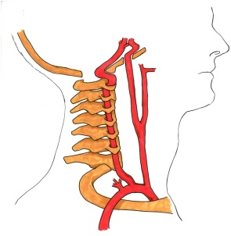
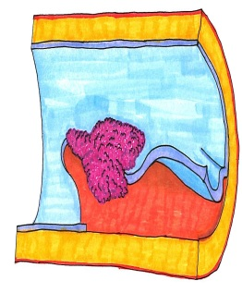

Let’s look at this some more. VBA strokes have been associated with many events. Activities leading to sudden or sustained rotation and extension of the neck have been implicated, including motor vehicle collision, sports, lifting, working overhead, falls, sneezing, and coughing. Case studies have been published calling them “Hairdresser’s Stroke” or “Bowhunter’s Stroke” because the necks are put into unusual and sustained positions. Does that mean that we should all stop going to hair dressers? Of course not. The incidence of these types of stroke is extraordinarily rare. They are believed to occur spontaneously, and other factors such as connective tissue disorders, migraine, hypertension, infection, vessel abnormalities, atherosclerosis, cervical spine surgery, cervical nerve blocks, radiation therapy and diagnostic angiography have all been identified as possible risk factors. It is difficult to connect the strokes to any particular event because they can take hours, days or even weeks to develop after the vessel damage occurs. No one really knows if they just happen spontaneously or from a specific event.

When weighing the risk/benefit ratio, there is no doubt that chiropractic care is a safe and effective and carries little risk when compared to the alternative. For example, risk of serious stroke or neurological complication resulting from a chiropractic neck adjustment = 1 in 5,800,000. Risk of death in motor vehicle accident =152 in 1,000,000, , Risk of death, per year, from GI bleeding due to NSAID use for osteoarthritis and related conditions = 400 in 1,000,000, Overall Mortality rate for spinal surgery = 7 in 10,000, Death rate from cervical spine surgery = 4-10 in 10,000 , Death by homicide = 61 in 1,000,000.

So, allow me to sum it up. While chiropractic does carry some risks, they are rare and generally benign. There may be a loose temporal connection between chiropractic upper cervical manipulation and stroke, but it has not been established to be causal in the literature. People who suggest otherwise are poorly informed or just unwilling to accept the prevailing science. Who knows? Perhaps they have a financial or emotional motivation. Chiropractic malpractice rates are among the lowest of all health care providers, and this is because actuaries have determined that there is low risk of complication. You and your clients should know the facts and can be assured that every effort is taken to make sure you are protected from any risk within the Shaw Chiropractic Offices. Email me at dr.shaw@shawchiropractic.com for a reprint of the study.

