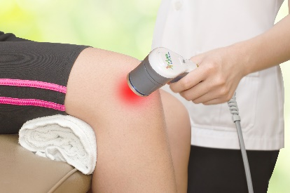
New Study on Low Level Light Therapy
About 10 years ago I started seeing an increase in literature popping up about Low Level Light Therapy treatments (LLLT). Back in my earlier practice days in the 80’s, chiropractors were not allowed to use needles for acupuncture treatments. So, many of us implemented what was called “Cold” Lasers that would stimulate acupuncture meridians but not generate any heat or damaging radiation. Use of high-power lasers has become ubiquitous in the medical world for a broad range of surgeries and cosmetic procedures but over the past decade or so we’ve seen a tremendous increase in the use of Class III and Class IV LLLT devices for a multitude of other conditions. A recent meta-analysis was published in the British Medical Journal (Vol 9, Issue 10), titled “Efficacy of low-level laser therapy on pain and disability in knee osteoarthritis: systematic review and meta-analysis of randomised placebo-controlled trials”. We’ll take a look at the results in this newsletter
LLLT is know by several other names including photobiomodulation, cold laser, soft laser biostimulation, low power laser therapy and more. They are distinguished from most medical lasers in that they do not produce heat (at least not enough to cause tissue damage). The wavelength of these LLLT devices is in the 600-700 nm for superficial tissues and 780-950 nm for deeper tissues. The power output for the devices ranges from several hundred milliwatts to as high as 50 -75 watts (pulsed). The primary use of the devices is for pain and inflammation, but the devices are also used for accelerating healing of biologic tissues and abundant dental research exists in this regard. Most commonly, the LLLT devices are used for muscle and ligament injuries and a broad range of connective tissue injuries that are exactly like those that your clients sustain. The focus of the above study was knee osteoarthritis (KOA)
This meta-analysis reviewed 22 trials related to knee osteoarthritis. Overall, pain was reduced using LLLT compared to placebo at the end of therapy and at follow-ups 1-12 weeks later. The peak benefits of the LLLT were appreciated between 2-4 weeks after the therapy was concluded suggesting there was an ongoing effect from the therapy even after therapy had been finished. More important, there was a statistically significant decrease in disability provided by the therapy. The authors conclude that “LLLT reduces pain and disability in KOA at 4-8 J with 785-860 nm wavelength and at 1-3 J with 904 nm wavelengths per treatment spot”. In other words, LLLT works (contrary to disbelievers like I used to be before using it on my bad knees!).
All of our offices have LLLT devices with power outputs ranging from 900 milliwatts through 10 watts to cover the healing low power treatments to the higher power pain control treatments. Much more can be said about LLLT and I’m happy to answer questions.

