The Significance of Cervical Degenerative Changes in Whiplash Patients
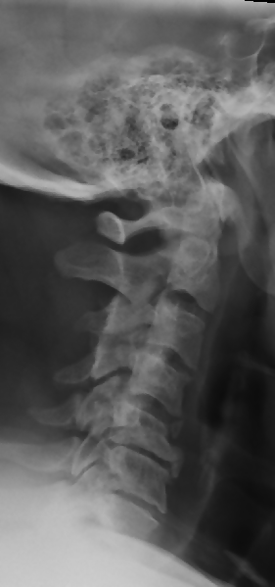
One of the most frequent questions physicians are asked to opine on is how pre-existing degenerative changes in the spine affect the outcomes of patients suffering “Whiplash” injuries (aka acceleration/deceleration injuries). There is some misunderstanding about what role degenerative joint disease (DJD) plays in injury causation and impairment. For purposes of this newsletter, I will use the term DJD, spondylosis, spondyloarthrosis, arthritis interchangeably since they all relate to the same normally occurring pathology, more or less.
Many may look at an imaging study or report that demonstrates degenerative changes and immediately assume that the person must have pain and related disability. However, we know from the literature that the existence of DJD on imaging has very little relationship to pain in a non-traumatic population. Many people with advanced degrees of DJD, like me, have absolutely no pain whatsoever. In fact, for my biomechanics master’s thesis, this is exactly the topic we researched and presented. To make a long story short, we found that in the absence of trauma, people with and without DJD had equal levels of pain. However, when the person with DJD is subjected to a traumatic event, they tended to have greater levels of pain than those who had trauma but did not have degenerative changes.
The findings of our research were supported by an August 5th 2019 longitudinal cohort study published in SPINE JOURNAL titled Association between cervical degeneration and self-perceived nonrecovery after whiplash injury.( Spine J. 2019 Aug 5. pii: S1529-9430(19)30899-X) The study looked for pre-existing degenerative changes on imaging studies. The researchers followed 121 patients who entered the Emergency Department with complaints of neck pain following a whiplash trauma. Each had CT scans and were followed for six months. The primary outcome measure included a self-reported YES/NO for recovery and secondary measures included the Numeric Rating Scale. In their interpretation they paid special attention to the facet joints of the cervical spine as a pain generator and not just degenerative changes involving the disc space.
The study results identified moderately degenerated facet joints were associated with chronic pain. In fact, 69.6% of facet joint degeneration subjects reported non-recovery versus 23.6% without any signs of degeneration. Interestingly, there was no association between disc degeneration and non-recovery. The authors conclude that “These results suggest that cervical degeneration, especially facet joint degeneration, is a risk factor for nonrecovery after whiplash trauma. We hypothesize that whiplash trauma can be a trigger for painful manifestation of previously asymptomatic facet joint degeneration”.
From an attorney’s perspective, this is valuable information that can be used to explain why some patients, with otherwise unimpressive impacts or vehicle property damage, may have delayed recovery or non-recovery resulting in permanent impairment. Obviously, in the absence of the prior degenerative changes the patient may have had full or improved recovery but the existence of the pre-existing spondyloarthrosis makes them the classic “eggshell” client.
I’d be remiss if I didn’t mention that these findings demonstrate why chiropractic approaches are tremendously beneficial for this population of injured patients. Facet degeneration is all too common and patients with facet arthropathy are particularly responsive to chiropractic interventions, specifically chiropractic manipulative therapy (CMT). This is because CMT procedures are focused on restoring facet joint mobility. The restoration of normal facet biomechanics results in the prevention of capsular adhesions which further restrict joint function. Untreated, the lack of joint mobility often results in further degenerative spine changes due to altered mechanical stress on the motor unit complex as well as impaired joint nutrition, and muscular imbalances.

