Vertebrogenic Back Pain
Many lay people believe that the majority of back pain is due to a disc pressing on the spinal cord or nerve roots. While we often find that people with back pain do have disc herniations of varying degrees, we also find a relatively low level of correlation between the disc herniations we find on MRI and the pain presentation of the patient. This low level of correlation brings up the question of the source of the pain and the resulting best treatment approaches. In previous newsletters, I have discussed some of the various sources of back pain that are not related to direct compression of the nerve roots from disc herniation. These have included sclerotomal pain from the connective tissues, facetogenic pain from the spinal facet joints, discogenic pain from the disc itself and others origins. In this newsletter we will look at another possible source of back pain that has been gaining recognition.
As the name would imply, vertebrogenic back pain is pain that originates from the vertebral bones of the spine. Typically, when referring to vertebrogenic pain we are referring to pain that originates from the vertebral body rather than the posterior elements such as the facets, pedicles or lamina. Obviously, when a patient sustains a compression fracture we realize they will have back pain. However, in the absence of visible structural changes on x-ray or other imaging, most doctors do not look to the vertebral body as a source of pain. This is in part due to the fact that there is not much to be done to treat this surgically…until now.
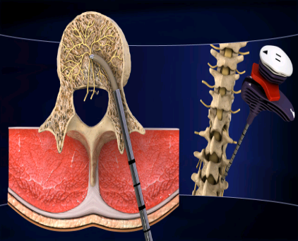
The FDA has just approved a new treatment for vertebrogenic back pain. The procedure is a minimally invasive nerve ablation technique developed by Relievant. Based upon research by Beaumont Health Systems principle investigator, Dr. Jeffrey Fischgrund, the FDA cleared the procedure. Dr. Fischgrund’s study looked at 225 participants (150 received the treatment and 75 received placebo) and results were supportive of the procedure and warranted further study. Dr. Fischgrund commented that “The system is proven to be safe and effective in clinical trials. It is much less invasive than typical surgical procedures to treat low back pain.”
The procedure is performed using a minimally invasive approach and can be done under low level anesthesia. The approach is similar to a vertebroplasty and can be done in a hospital or procedure suite. A cannula is inserted percutaneously through the pedicle and into the vertebral body. A radiofrequency device is inserted through the cannula and the radiofrequency is delivered to the basivertebral nerve within the vertebral body to ablate the nerve
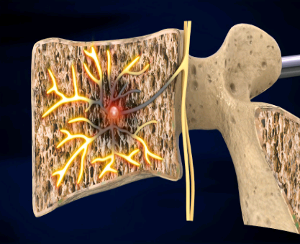
What is the Basivertebral nerve and its innervation? The Basivertebral nerve provides sensory innervation to the vertebral body and gives off branches to the subchondral bone of vertebral endplates. What is interesting is that it joins with divisions of the sinuvertebral nerve which is related to the other structures previously described as pain generators. This common innervation for many of the structural pain generators makes it increasingly difficult to pinpoint the source. While the technique described is not currently available through the pain management doctors or spine surgeons in Connecticut, it is an up and coming procedure which will be both diagnostic and therapeutic in the properly selected populations. These populations will most likely be those that have failed other pain management procedures but have intractable pain possibly originating from the disc.
How does chiropractic treatment play a role in treating chronic pain from these various pain generators?
Current theories related to pain management and pain modulation find a common thread in the concepts of deafferentation or more likely dysafferentation. Dysafferentation results when there is alteration of the dominant sensory input which often functions as the neurological system’s “white noise”. This white noise is a stabilizer or buffer which allows for proper modulation of other sensory input. By far, the greatest sensory input to the brain comes from the many joints of the body that send messages about movement and position. These position receptors are called proprioceptors and all joints of the body have them. When a joint is moving improperly (too much or too little) the afferent (sensory) signals are altered. When the joints of the body are locked or fixated (often from trauma) there is a decrease or absence of proprioceptive feedback to the brain which allows pain nerves (nociceptors) to become the dominant input. Chiropractors are experts in identifying joint dysfunction and also in the restoration of proper function through manipulation, exercise and postural education. The restoration of normal joint mechanics allows for return of the normal sensory balance and a return to a pain free state. In other words, in the absence of the “white noise”, the body only perceives the pain. Adding the “white noise” back into the mix allows for normal sensory modulation. Of course, this concept also works with the well accepted Gate-Control theory of pain (Melzack and Wall) which suggests that competition exists for sensory input and that if you dominate the majority of sensory input with non-pain impulses the pain will not be appreciated as greatly. TENS machines work on the Gate theory by introducing electrical input that competes with the body’s pain input thereby reducing the pain perception.
As my wife would say, that may have been TMI (too much information) but I hope that I made the concept more understandable. If you have any questions about vertebrogenic pain or any of the other topics discussed in this or previous newsletters feel free to reach out to me. I’d also welcome suggestions for future newsletters.

