Facet Syndrome
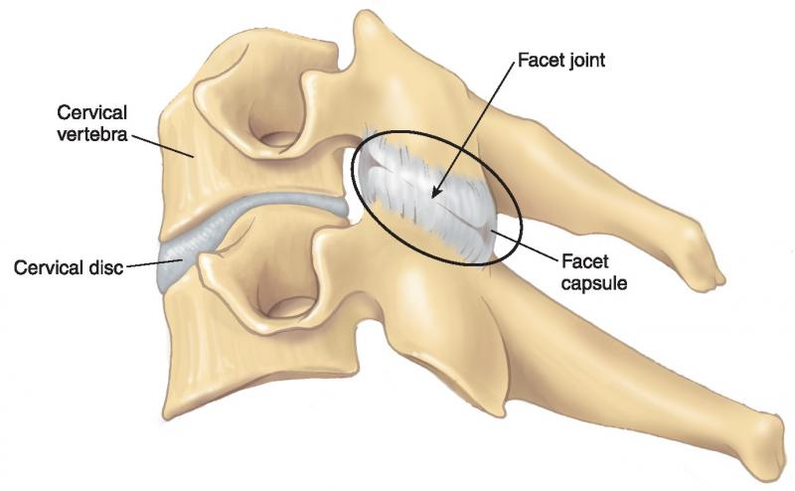
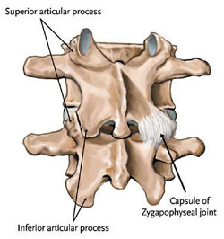
The concept of facet joint mediated pain is not a new concept but it is one that is overlooked frequently in the medical legal world and commonly misinterpreted as radiculopathy by many lay “experts”. Facet joint pain, also commonly known as facet syndrome, is pain that originates from the posterior joints of the vertebral motor unit. The joints of the vertebral motor unit include two adjacent vertebra and the related intervertebral disc in the anterior and the two facet joints in the posterior. These posterior joints are also known as the Apophyseal joints, Zygopophyseal joints, Zed joints, Z joints. For purposes of this newsletter, I will be discussing primarily Lumbar Facet syndrome but most of the concepts will apply also to the cervical spine.
Characteristic symptoms of facet mediated pain include localized unilateral spine pain, Localized facet or transverse process pain to palpation, pain directly over the joint capsule, lack of radicular features (dermatomal distribution or motor weakness), pain reduced on flexion, Pain worse with extension and loading, referred pain not extending beyond the knee or elbow, pain reduction after diagnostic facet or medial branch blockade.
It is important to point out that facet joint pain, both in the neck and lower back, may have a referral pattern to the extremities but it does not follow a regional dermatomal pattern. A dermatomal pattern of referral is expected with a disc herniation with resulting nerve root involvement or other nerve root compromising lesions and will follow the anatomical distribution of the sensory root for that nerve. Thus, the term radiculopathy (radic = root, pathy = patholology/disease). If the motor portion of the nerve root is involved the presentation will involve motor/strength changes in the muscles related to that nerve root (also known as the myotome). This is not the case with a facet syndrome which will not result in abnormal muscle strength (other than from pain related weakness) or a dermatomal distribution of sensory abnormality. The referral pattern of facet pain is often difficult for the patient to characterize but will generally follow a sclerotomal pattern. Sclerotogenous pain, pain originating from embryological related tissue, will not have associated weakness and will be “non-regional”, meaning that it is non-dermatomal. The graphics below demonstrate the difference between sclerotomal and dermatomal distributions from the cervical region.
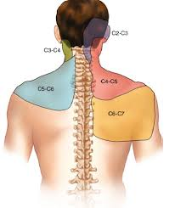
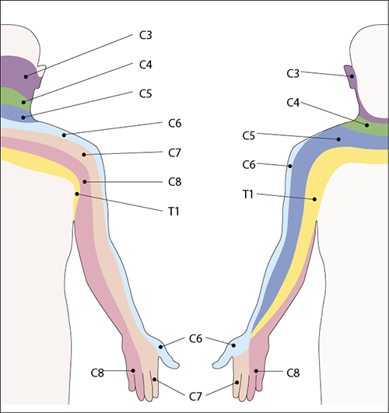
The mechanism of injury in motor vehicle trauma can explain why patients may have injury to the facet joints or the related connective tissue structures resulting in facet mediated pain. For example, in a rear impact injury there are multiple vectors of force that are exerted on the spine. These include flexion, extension and perhaps rotation. All three of these are normal physiologic movements but due to the coupling of these forces and the addition of translation, which is a non-physiologic movement, the axis of rotation changes. This axis of rotation is often called the instantaneous axis of rotation and simply means that the normal focus of movement changes. This explains why whiplash or other acceleration traumas can adversely affect the disc joint but even more so, the vulnerable facet joints. The facet joints are vulnerable to capsular tearing, chondral injuries to the articular surface, fractures of the superior or inferior articulating process and in the cervical spine articular pillar fractures. Any of these potentially injured structures can result in facet mediated pain.
If there are fractures, dislocations or very significant chondral injuries, imaging may show abnormalities. Imaging studies that may be positive include MRI, radionuclide bone scans, digital radiology and CT scans. Most facet pain is not related to fractures or imaging sensitive chondral injuries and must rely on standard orthopedic tests which are objective tests, yet subjectively interpreted. There is no way to truly objectively demonstrate the presence of facet mediated pain in the absence of significant anatomical lesions. However, diagnostic facet blocks or medial branch blocks may help identify the pain generator as the facets (or related somatic tissues) and that could lead to a more permanent approach to pain control using radiofrequency ablation.
Facet mediated pain can also be the result of altered joint biomechanics. This explains why chiropractic manipulative approaches have proven to be valuable in managing patients with facet mediated pain. Altered mechanics from traumatic events can be restored to normal using chiropractic techniques. These techniques focus on restoring the normal joint motions on a segmental level rather than a gross level. The appearance of full ranges of motion on visual or inclinometric evaluation can be misleading and overlook the segmental mechanical lesions that can only be identified by an experienced and well trained chiropractic physician. Overlooking these segmental mechanical lesions can result in hyper and hypo mobility of adjacent joints of the spine. Overtime, this can result in chronic degenerative changes due to the transfer of mechanical stress. This is the same mechanism as occurs when there is a. surgical or congenital spinal fusion with adjacent segment disease. Therefore, chiropractic approaches are beneficial for both controlling the pain related to acute facet related symptoms and also preventing the chronic degenerative changes seen when left untreated for a prolonged period of time. Even when the joint damage is too great for complete recovery, chiropractic approaches can offer the patient relief that otherwise may require lifelong use of medications, injections and eventually surgery.
For more information about facet mediated pain email me at Dr.Shaw@ShawChiropractic.com

