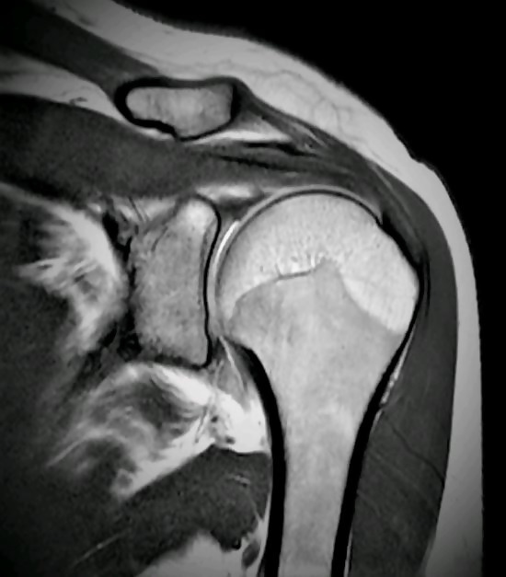
MRI Reliability for Shoulder Pathology
The false positive rate for disc herniations on MRI can be as high as 60%. Even the studies that are in the lower range identify nearly a 30% false positive rate (A false positive indicates that a condition or attribute is present when it actually is not). For that reason, most practitioners will give very little clinical value to abnormalities found on MRI that do not clinically correlate with a patient’s presentation and history. A study just published in the Journal of Shoulder and Elbow Surgery titled Bilateral magnetic resonance imaging findings in individuals with unilateral shoulder pain addressed the reliability of findings on shoulder MRI.
This prospective study was done on 123 subjects with unilateral shoulder pain. Each had comparative MRI examinations of both shoulders. They all presented with unilateral shoulder pain with no signs of adhesive capsulitis, no substantial range-of-motion deficit, no history of upper-limb fractures, no repeated shoulder dislocations, and no neck-related pain. The studies were interpreted independently and randomly by 2 examiners: a board-certified, fellowship-trained orthopedic shoulder surgeon and a musculoskeletal radiologist.
Not surprisingly, abnormal MRI findings were prevalent in BOTH the painful and pain-free shoulders. With the exception of full thickness tears in the supraspinatus tendon and degenerative arthritis, which were found 10% more in the painful side, the MRI findings were comparable and not correlated with the painful shoulder. The authors conclude that “Most abnormal MRI findings were not different in frequency between symptomatic and asymptomatic shoulders. Clinicians should be aware of the common anatomic findings on MRI when considering diagnostic and treatment planning”.
In the context of documentation and establishing causation, it is important for the attending doctor to line up the dominos. What I mean is that they can’t just identify a shoulder MRI abnormality and opine, with any degree of authority, that it’s the underlying etiology of a patient’s pain AND that it is causally related to the trauma. We see medical doctors and chiropractors do this all the time with minor disc bulges on spine MRIs when they say the findings are 100% causally related to the trauma, despite a medical history and injury mechanism that cannot support their opinions. The first thing an attending physician must do is determine if there is a prior history of shoulder problems on that patient. If not, that’s great but if there is then it is imperative to document the nature of the prior shoulder condition and the extent to which it was active and functionally disabling. Then, they should understand the injury dynamics so that they can explain how the injury could have occurred from a biomechanical perspective.
A doctor that has clarified the patient’s history, explained the biomechanical mechanism between the injury and the trauma and correlated it to the shoulder MRI findings has established what I call the triple match. They have established a causal relationship between the injury and the MRI findings which is defensible within a reasonable degree of medical probability. But what happens if the history doesn’t exclude prior issues? What if the nature of the injury mechanism is not directly consistent with the MRI findings? The approach must then be different.
First, let’s look at a patient with a prior shoulder injury on the involved side. Certainly, the defense inclination will be to assign 100% of the patients’ problem to the prior diagnosis but is that reasonable? That depends on the status before the injury occurred and a comparison of the medical records both before and after the injury. Even if a patient has a prior history of active shoulder problems, it is important to assess if they are now functionally worse off. Let’s face it, a prior injury can be a hurdle to overcome, but it also represents that a patient is more vulnerable to greater injury and one that has a far greater impact on their ADLs. It is reasonable for a doctor to opine that a patient with a prior 5% impairment, who now has 10% impairment, is more than just two times worse off than before. In other words, the second 5% impairment that makes that patient 10% impaired represents a functional level far worse than the original 5%. The bottom line is that, the numbers don’t tell the entire story. This is your classic eggshell client. Make sure the doctors address this compounding and summation effect of multiple injuries or impairments.
What about the mechanism of injury being incongruent with the injuries? First, patients are notoriously poor historians. They either don’t remember important details or they remember them inaccurately. Without coaching the patient, the doctor needs to explore likely injury mechanisms with the patient to see if one “rings a bell” with the patient. Simple questions relating to their body position at the time of impact, the direction of a fall and what happened when the hit the ground, secondary impacts and so forth can reveal injury mechanisms that may not be recollected immediately by the patient or even have been considered by them until they are discussed. Again, to be clear, the questioning is not done to coach the patient, but help them recall and explore the incident more clearly so that an objective observer can understand how the type of injury reported on an MRI and documented by the doctor is reasonably and plausibly related to the trauma.
The doctors at Shaw Chiropractic Group understand these considerations and make every effort to assure that imaging findings correlate clinically, historically and biomechanically. Click here for a copy of the study referenced above.

