Regenerative Medicine
I’ve noticed an increased volume of literature being published on the topic of “Regenerative Medicine” (RM). While the use of RM is not limited to orthopedics, that is our primary of interest and therefore the focus of this newsletter. RM is the process of replacing, engineering or regenerating human cells, tissues or organs to restore or establish normal function”. In the world of orthopedics it seems to have focused on the use of approaches like Platelet Rich Plasma (PRP), Autologous Chondrocyte Implantation (ACI) and Adipose Derived Mesenchymal Stem Cells but these are just the most popular. These approaches are being used to stimulate the body to regenerate the damaged tissues thereby avoiding the need for surgery or other approaches that may have short term benefit but long term consequences.
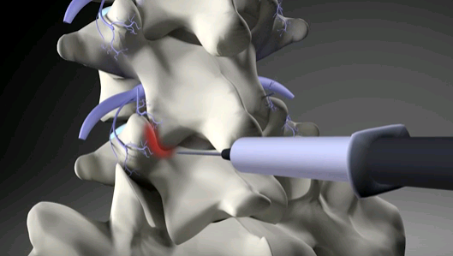
I just read an interesting study which has been accepted for publication in the journal Pain Practice. The study is titled “A Prospective Study Comparing Platelet Rich Plasma and LA/Corticosteroid in Intraarticular Injection for the treatment of Lumbar Facet Joint Syndrome”. It is particularly interesting because the facet joints of the cervical spine and the lumbar spine are the most likely source of axial and referred pain in the trauma cases that we see in clinical practice. This contrasts with the popular belief that the intervertebral discs are the primary source of spine pain after motor vehicle trauma.
Figure 1: Facet Injection
Traditionally, doctors will inject the facet joints with long acting corticosteroids for pain control (just like other joints of the body) but that approach is generally a short term solution. In fact, the steroids, along with anesthetic medications, are often used for diagnostic purposes as much as therapeutic purposes. If they work, the doctors would then progress to use techniques to lesion the innervating sensory nerves thereby blocking the pain signals for a longer time. The problem with that approach is that the nerves will eventually regenerate and the pain is then recurring because the underlying tissue damage is never addressed. That’s where RM may play a more effective and curative role.
The study looked at the short and long term effects of both approaches using 46 randomized subjects. The researchers quantified the efficacy of the treatments using outcome measures including Pain Visual Analogue Scale at rest and in flexion, Roland-Morris Disability Questionnaire, Oswestry Disability Index and the Modified McNab criteria. Outcome measures were used at 1 week, 1 month, 2 months, 3 months and 6 months.
At baseline there were no significant differences in the 46 subjects. Both study populations showed statistical improvement compared to the baseline after 1 month. At 6 months, the corticosteroid group had lowered outcome measure scores while the PRP group had improved scores over time. This study suggests that regenerative medicine approaches can not only reduce pain but may offer the long term benefit of actually healing the damaged tissues so that recurrence of the symptoms does not occur. In fact, theoretically and optimally, the tissues could return to their pre-injury state or even better! For someone like me who has had 5 knee surgeries I see this as an opportunity to avoid joint replacement in the future.
Regenerative Medicine is a hot topic today because it offers the potential for real healing and more than just pain control. At this point, it is still in its relatively early stages but we’ve seen tremendous acceleration in the development of more refined approaches and better techniques for harvesting the stem cells and growth factors and introducing them more effectively into the areas of need.

Definitions
Platelet-rich Plasma (PRP) is blood plasma that has been enriched with platelets. As a concentrated source of autologous platelets, PRP contains several different growth factors and other cytokines that can stimulate healing of soft tissue.
Mesenchymal Stem Cell Therapy treatments use autologous harvested stem cells from various sources which can differentiate into cells that are part of the musculoskeletal system. They can help to form trabecular bone, tendon, articular cartilage, ligaments and part of the bone marrow. Therapy is done by harvesting the cells and placing them in the tissues that are damaged in the hope they will differentiate into new tissue of the same type and better quality than the already damaged tissues. (See www.Regenexx.com)
Autologous chondrocyte implantation is a treatment that repairs damaged articular cartilage. Cartilage is first harvested from the joint and then enzymatically refined. The cells are then grown in vitro for 4-6 weeks and then re-introduced into the joint surgically. The introduced cells adapt themselves to the new environment and then form new cartilage. ( See www.Carticel.com)

