Surgery for the Uninsured on a Letter of Protection

Some of us remember the early 90’s when Connecticut lost its mandatory basic reparation benefits of $5,000. Other than practices like mine, there were practically no medical providers willing to accept a letter of protection. Surgery was out of the question because the costs far exceeded the 5K benefit. It was nearly impossible to get an MRI or specialty consultation. At least back then, many people had personal health insurance with reasonably small deductibles and co-payment provisions. They still had some chance for access to the doctors they needed.

Times have changed and more providers now accept LOPs for your clients care. At the same time, the number of people that are uninsured has risen to over 30 million. Even with the Affordable Care Act just days away, people with private policies or exchange policies will have deductibles of many thousands of dollars and co-payments of 30-50% which will make access to care cost prohibitive.

Specifically as it relates to surgery, the financial and logistical barriers have become almost insurmountable. To address this, a new industry emerged known as “Law Suit Funding”. This is commonly known as a law suit loan even though the service providers are resolute that they are not loaning money. Rather they claim they are buying a growing security interest in a law suit. For over 10 years these companies have loaned your clients money. Unfortunately, the costs usually start at 100% of the provider’s fee and then add interest that can be as much as 30%/year or more. Of course, there are other costs like documentation fees, application fees, filing fees, and more that may be added to the loan principle. By the time you settle your client’s case your client may owe 200-300% of the original amount borrowed. There is no provider discount because the providers are paid up front by the law suit funding company. If the case settles sub-optimally and your client doesn’t net a fair amount they may refuse the settlement. Even if the law suit funding company cooperates and is willing to reduce their balance, it can never be below their costs which already started at an inflated number.

The preferred alternative to Surgical funding is Surgical Factoring. Here are some of the benefits of factoring over funding. There is no interest on the secured amount. There are no upfront or backend fees. The agreement is non-recourse so that no recovery means zero balance due. Your client pays no more than any other person receiving care on a cash basis. It’s offered under the guarantee of your letter of protection. With Surgical Factoring, the medical providers agree to accept your LOP with the understanding that the factor will immediately buy the accounts receivable. In exchange for up front payment, providers discount the fee to the factor. In other words, the factor profits from the providers discount while the funding company profits off your client.
 | Surgery Factoring | Surgery Law Suit Funding
Interest | NONE | Can be as high as 30+%
Fees | NONE | May include up front fees
Recourse | NON-RECOURSE | Depends on provider
Sample payback of 30,000 in 5 years | $30,000 (NEVER INCREASES) | $80-$110,000 (depending on terms)
Who pays for the financial service | Providers | Your client

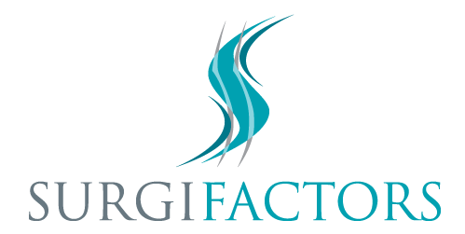
While the concept of factoring goes back many years, the application of this approach specifically to surgical candidates is being launched in Connecticut by my newly formed company, Surgifactors. The obvious benefits of factoring are described above and you can learn more by visiting www.Surgifactors.com. Added benefits of working with Surgifactors are that you are dealing with a doctor who has practiced in the medial legal arena for 30 years and has an understanding and appreciation of the needs of your clients and your practice. If you would like more information please contact me at the numbers below or call Surgifactors at 855-313-9608

