**The Visual Analogue Scale as an Outcome Assessment Tool**

Outcome assessments (OA) are tools that evaluate patient status and progress. They have been used for years in research and in private settings. OAs have become much more widely used in recent years as doctors are challenged by their peers, and carriers to support their management recommendations and opinions regarding function and outcome.

A review of the literature identifies over 28 different scoring systems just for lower back pain. The AMA Guides now recommends the use of OAs when performing permanent impairment evaluations. Despite the large number of OA tools available, no particular OA tool has consistently been proven to be more valid, reliable or clinically sensitive than any other. In other words, while all OA tools have gone through validity testing none are necessarily better than others, despite claims made by the researchers themselves or by parties with interests of their own.

Probably the oldest and most well known OA tool is the visual analogue scale (VAS). The visual analogue scale is a line, usually 10 cm long, with each end-point clearly marked and described. Patients are asked to pick a number on the line that represents their pain level or intensity. This numeric value provides a quantitative variable that can be inserted into standard statistical tests for research or used clinically as a data point for follow-up assessments.

Many attorneys have questioned the simplicity of the tool and the value in their client’s documentation. You should know that the VAS is an accepted OA tool that has been repeatedly validated in the research. In fact, many other OA tools are validated against the VAS as a standard. It is a statistically reproducible method for scoring patient outcomes, particularly when used serially throughout a patients care to show improvement or lack thereof.

Other OAs have recently been suggested as being the gold standard. These include the DASH for upper extremity evaluations, Roland-Morris for back pain, Neck Pain Disability Index for neck pain, Oswestry for function, SCL-90R, etc. However, few of these have been validated for gender, ethnic, language or cultural bias. In some of the populations we attend to these are very real considerations. As an example, under-educated populations or people with language barriers are unable to consistently complete complex and sophisticated OA questionnaires which can be many pages long and confusing. For these populations, a simple VAS diagram is sufficient to determine pain intensity and demonstrate a trend towards improvement or stationary status. When needed, more sophisticated OAs can be utilized to define other more specific functional limitations but as a guide to treatment efficacy the VAS tool is more than sufficient.

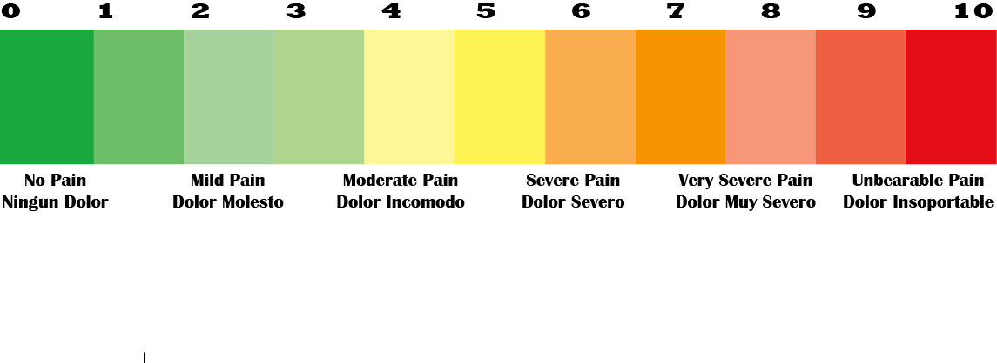Below and attached is a sample of the VAS that we use in our practices. We have added a color scale and bilingual verbiage to add a multimodal experience for our patients and to improve its accuracy. In the end, it is the doctors experience with the patient over many encounters and time that ultimately defines the efficacy of treatment and the outcome of the patient. Until one OA demonstrates significant superiority over all others you should be comfortable knowing that the VAS scale can accomplish the same clinical and documentation benefit as almost any other OA tool. Your feedback and comments about our newsletters are always welcome and appreciated. [Dr.Shaw@ShawChiropractic.com](mailto:Dr.Shaw@ShawChiropractic.com)

.

**List of Common Outcome Assessment Tools**

|  |
| --- |
| ABC (Activities-specific Balance Confidence Scale) |
| ASES (American Shoulder and Elbow Surgeons Score) |
| Back illness pain and disability nine-item scale |
| Back pain functional scale |
| Back pain interference scale |
| Bournemouth questionnaire |
| Canadian Occupational Performance Model – (COPM) |
| Chronic Pain Scale |
| Clinical back pain questionnaire |
| Croft Disability Questionnaire |
| Dallas pain questionnaire |
| DASH (Disabilities of arm, shoulder & hand) Score |
| Disability rating index |
| Distress and Risk Assessment Method (DRAM) |
| FABQ (Fear Avoidance Beliefs Questionnaire) |
| Fear-Avoidance Beliefs Questionnaire |
| Fugl-Meyer Assessment |
| Functional outcomes questionnaire for spinal disorders |
| Functional rating index |
| General function score |
| Goal Attainment Scale |
| Human Activity Profile |
| Jan van Breemen functional scale |
| Knee Injury and Osteoarthritis Outcome Score (KOOS) |
| LEFS (Lower Extremity Functional Scale) |
| Low back outcome score |
| Low back pain rating scale |
| Lower Extremity Functional Scale |
| Lysholm Score |
| McGill Pain Questionnaire |
| Million visual analogue scale |
| Modified Work Apgar |
| NASS lumbar spine outcome assessment *instrument* |
| NDI (Neck Disability Index) |
| Neck Disability Index |
| NPRS (Numeric Pain Rating Scale) |
| Numeric Rating Scale |
| Occupational role questionnaire |
| Orebro Musculoskeletal Pain Questionnaire (OMPQ) |
| Oswestry disability index |
| Outcome measure in lumbar spinal stenosis |
| Outcome Rating Scale |
| Pain Beliefs & Perceptions Inventory |
| Pain Catastrophising Scale (PCS) |
| Pain Disability Questionnaire |
| Pain response to activity and position questionnaire |
| Pain Self-Efficacy Questionnaire (PSEQ) |
| Patient-speciﬁc functional scale |
| Patient-Specific Functional Scale |
| Penn Shoulder Score |
| Physical impairment scale |
| PI-NRS (Pain Intensity Numerical Rating Scale) |
| POMA (Performance Oriented Mobility Assessment |
| Quadruple Visual Analog Scale |
| Quebec Back Pain Disability Scale |
| Quebec Back Pain Disability Scale |
| Quick DASH |
| Resumption of activities of daily living scale |
| Roland–Morris disability questionnaire |
| Short Form 36 Bodily Pain Scale (Sf-36 Bps) |
| Short Form McGill Pain Questionnaire |
| Shoulder Pain and Disability Index |
| SPADI (Shoulder Pain and Disability Index) |
| Spinal pain independence measure |
| SPPB (Short Physical Performance Battery) |
| Symptom Check List 90R |
| Upper Extremity Functional Index |
| Vernon & Mior Cervical Spine Score |
| Waddell disability index |
| West Haven-Yale Multidimensional Pain Inventory |
| Whiplash Disability Questionnaire |
| WOMAC (Western Ontario and McMaster Universities Osteoarthritis Index) |